Use graphic organisers to embed writing skills development in TVET

This resource supports the development of level 1, stage 3 design capabilities.

# Contents

Contents 1

What are foundation skills 1

Approach to embedding foundation skills in TVET 2

Know the demands 4

Know the learners using diagnostic assessment 1

Know what to do 4

|  |  |
| --- | --- |
| Logo for Commonwealth of Learning (image including a book and a globe) | This resource was created by Commonwealth of Learning for the TVET Professional Development Toolkit for the Pacific |

# Introduction

This resource follows a three-step approach to embedding foundation skills in TVET teaching and learning.

1. Know the demands: examine the standard to find the foundation skills needed.
2. Know the learners: use diagnostic assessment to find learners’ existing skills.
3. Know what to do.

This resource supports you to develop tools to use in Step 3.

Graphic organisers are a useful way to represent ideas. You can adapt these activities to your context, based on the course demands and your learners’ needs. They might spark some other ideas for you to try.

If you’re not sure about any aspect of these, it can be useful to talk this through with an experienced trainer.

# What are graphic organisers?

Graphic organisers help learners arrange their ideas visually before writing. They break down complex information into manageable parts.

You can use graphic organisers to encourage learners to explore connections between key concepts and terms. They are also useful for planning and structuring written work, enhancing clarity, and coherence.

We will look at four types:

* Mind maps
* Concept maps
* Venn diagrams
* Fishbone diagrams

# The benefits of using graphic organisers

## Benefits for learners

For learners using graphic organisers can be a useful way to:

* write key words and build vocabulary
* become familiar with new content
* organise ideas
* see the bigger picture alongside more detail
* brainstorm ideas
* work from single words and move toward sentences.

## Benefits for trainers

For trainers, graphic organisers are a useful way to:

* spark learners’ creativity and innovation
* find out learners’ current knowledge on the subject
* develop a visual representation of the subject
* show the relationships between different topics.

# Ways to use graphic organisers

* Use graphic organisers as you work through the new materials or to explore a case study/scenario.
* Work together on a whiteboard, in small groups with large paper, or in pairs.
* Encourage learners to organise their ideas for a report or project plan.
* Use as an assessment task completed individually:
  + Diagnostic assessment
  + Formative assessment
  + Summative assessment.

# Mind maps

A mind map starts with a main idea in the centre. Branches spread out to show related ideas or topics. Each branch can have additional sub-branches, to include complex information in an easy-to-read format.

Mind maps encourage creative thinking by allowing learners to make connections between ideas. This type of graphic organiser is useful for:

* brainstorming
* planning projects
* breaking down large topics into smaller parts.

## Example of a mind map

This was made to begin thinking about different types of graphic organisers.

Graphic organisers 
1. Concept maps
-Similar to mind maps but less constrained
-Can be difficult to understand
-Shows relationships between ideas
-More free-flowing and can be creative
2. Fishbone diagram
 - Good to show causation
 - Good for multi-levelled problems
 - Useful for collaborating
 - Not as intuitive as other GOs
3. Venn diagrams
 - Easy to draw
 - Shows overlap
 - Not good for too many ideas
 - Shows relationships 
4. Mind map
 - Simple to draw
 - Good for collaboration
 - Can use for complex ideas
 - Great for brainstorming

# Concept maps

Concept maps represent relationships between different ideas. They start with a main idea, often at the top or centre, with lines connecting to related concepts or subtopics.

You can label each connection to show the type of relationship and clarify links between ideas.

Concept maps are useful for understanding complex topics by breaking them down into smaller, interconnected parts. They support critical thinking by encouraging learners to see connections and hierarchies within the information.

## **Examples**

A concept map can be created in a range of formats. Choose a format that suits your topic, your learners, and you own style.

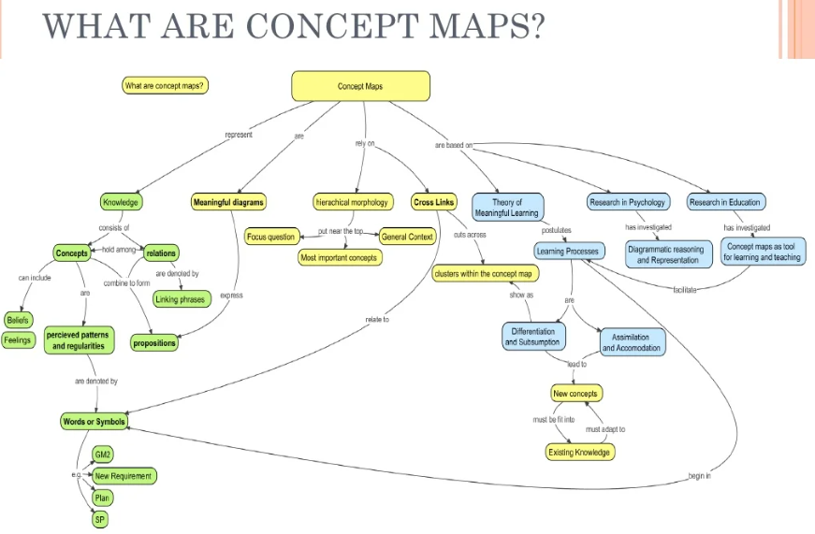  
from [Concept map vs mind map | PPT (slideshare.net)](https://www.slideshare.net/muralidharanl/concept-map-vs-mind-map-6287765)

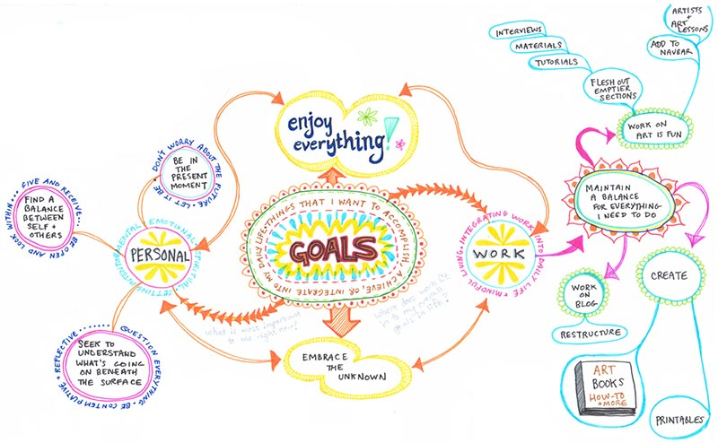  
From <https://www.art-is-fun.com/create-a-mind-map>

## Further learning resources on concept maps

* [Agriculture concept map for developing writing skills](https://youtu.be/W1fygdtfsw0?si=j6dSNuPh-GXU1AVR)
* Watch a 9 minute video on YouTube from University of Waikato.
* [Why Mind Mapping?](https://www.mindmeister.com/blog/why-mind-mapping/)
* Read a blog post on mindmeister.com, including videos, links, and diagrams.
* [Bubble.us](https://bubbl.us/v3/home.php)
* Try Bubbl.us, a mind-mapping app that you can access at no cost.

# Venn diagrams

Venn diagrams use overlapping circles to show what is similar and different between two or more groups. The middle (overlapping) part shows what is shared, while the outer parts show what is unique to each group.

This type of diagram makes it easier to see how things are alike and different. They help learners to compare and contrast ideas or groups in a clear way.

They are useful for organising information and understanding relationships between ideas.

## Example of a Venn diagram

Exploring the similarities and differences between fish and mammals.

Two circles that are slightly overlapping.
Circle 1. Mammals
Warm-blooded
Birth live young
Have hair or fur
Breathe with lungs
Circle 2. Fish
Cold-blooded
Lay eggs
Scaly skin
Breathe with gills
In the overlapping area:
An internal skeleton and backbone.

Fishbone diagrams

A fishbone diagram helps identify causes of a problem by organising them visually. It looks like a fish skeleton, with the "head" showing the main problem and "bones" showing different causes.

Each "bone" represents a category of causes, like people, process, or materials.

It helps break down complex problems into smaller parts, making it easier to understand. Fishbone diagrams are useful for brainstorming possible causes and finding solutions.

## Example of a fishbone diagram

Analysing the problem of low student engagement

Outdated and not relevant

Limited multimedia

Don’t match learners’ interests

Not enough applied examples

Teaching methods

Materials

Classroom environment

Student factors

Activities not interactive

Too much lecture style

Not enough discussion

Lack of variety

Difficult to do group work

Room is noisy

Too many distractions

Lighting is not good

Little prior knowledge

Varying levels of English

Low interest in topics

Personal issues