What makes a good learning resource?
This resource is designed to help you create good learning resources. The key principles of creating effective learning resources are listed below, followed by an example.
Read this resource before you start planning the learning resource and review it regularly as you are developing it. You could use this resource as a checklist when you have finished to make sure the principles have been applied.
An effective learning resource is:
Clear, concise and accurate
- The purpose of the learning resource is clearly displayed
- Learning content relates to the learning outcomes
- Information is up-to-date and relevant to the topic
- Critical information is highlighted or made obvious to the learner
- Learning resource is reviewed and checked for accuracy by subject matter experts

Relevant to the learner
- The learners’ skills, knowledge and experience is considered
- Real workplace examples are used to help learners connect their learning to their own role or situation

Easy to understand
- Instructions are clear and uses simple language
- Learning content supports learners to understand concepts and integrate them into their role
- Technical terms and acronyms are explained and used appropriately
- Graphical elements are used to compliment the learner’s understanding

Displayed in a logical order
- Learning resource is well-structured and appropriate for its purpose
- Similar content is grouped together
- Content is displayed in a logical order that allows the learner to understand the process

Designed with the learner in mind
- Learner needs and characteristics are considered in the learning design, for example, their learning environment, literacy and numeracy, IT literacy, knowledge/skill-level etc
- Relevant activities are included to reinforce their learning

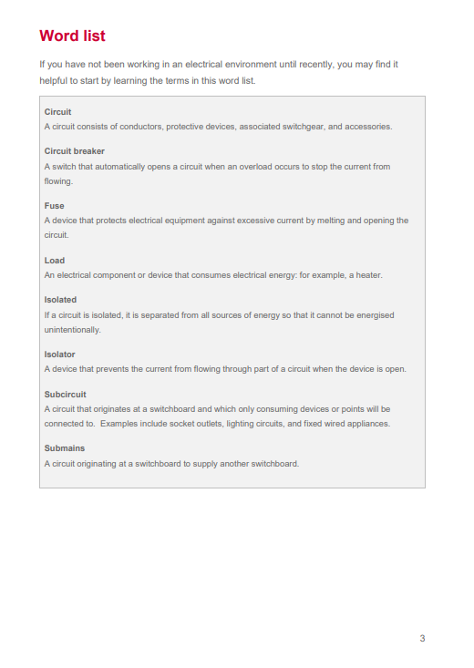
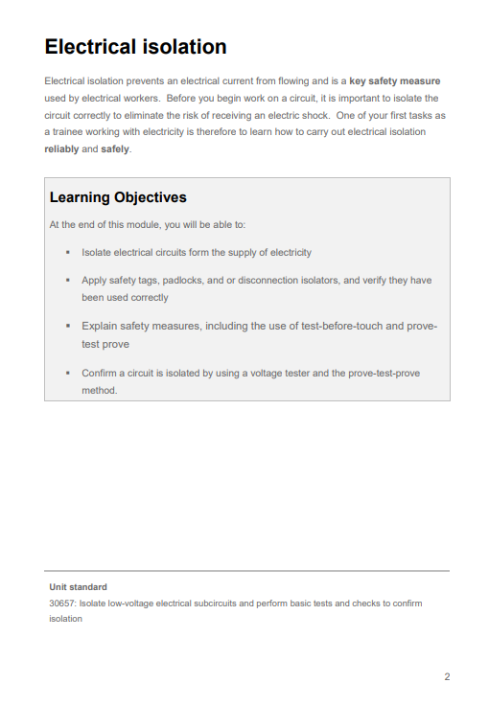
Here are some sample pages of the learning material for electrical subcircuits.
An introduction to the topic gives the learner context of what they will be learning.
Page numbers makes it easy for the learner to reference if needed.
Word lists help learners understand terms covered in the assessment.
Clearly written learning objectives shows the purpose and key concepts to the learner.
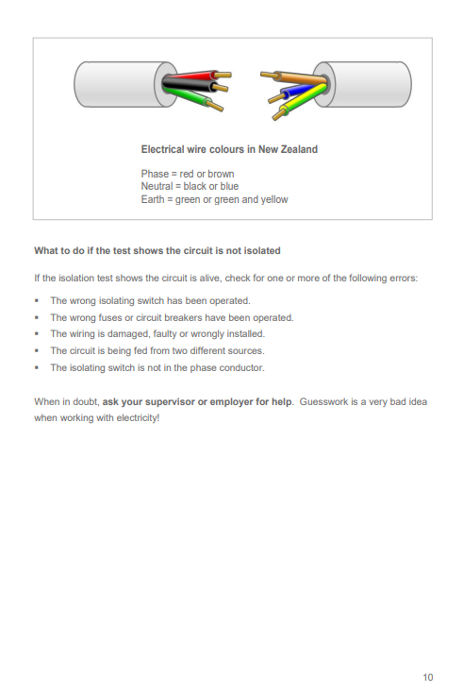
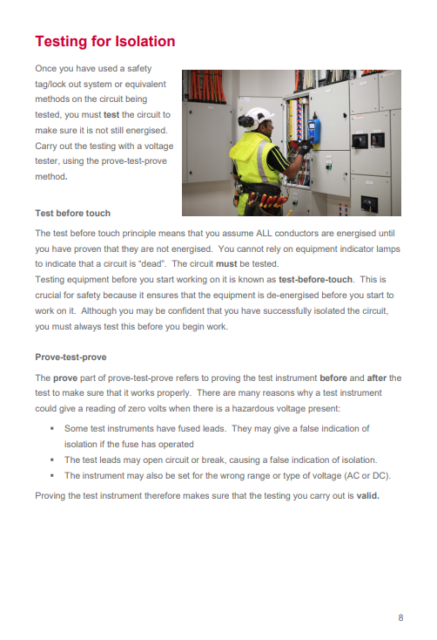
Use of bulleted lists highlight key points and draw attention to important information.
Diagrams help learners visualise concepts.
Headings and subheadings indicate the topic groupings. This helps with the flow and location of content.
Use of images helps provide context to the learning.
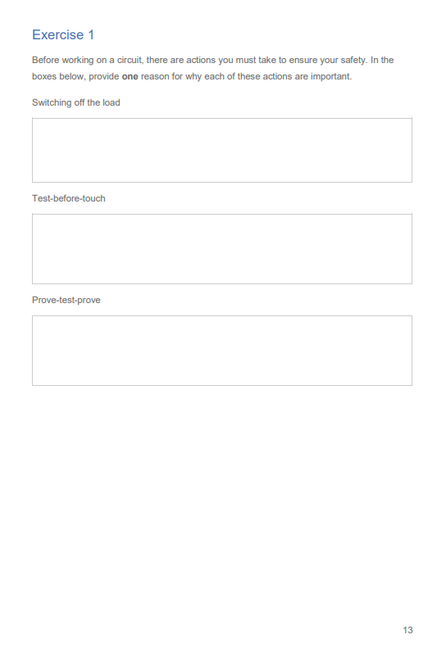
Activities can include questions that help engage the learner and reinforce their learning. This could be reflective questions, open text questions, multi-choice questions, or practical tasks.

