Writing Assessment Questions

This resource is designed to help you write good assessment questions. It covers the different types of questions and the general rules for writing good questions. It will help you to select the most appropriate question type for the evidence needed, as well as ways to provide variety for the learner.

There are two kinds of assessment questions - one is objective and the other is subjective.
Objective questions are straight forward and based on facts where the learner’s answer is either right or wrong, or true or false. For these questions the learner selects a response or writes a word or short phrase.
Subjective questions require the learner to form their answer using their own words. Markers use their knowledge, experience and in most cases an assessor guide and marking schedule to interpret and evaluate the learner’s response.

Examples of assessment questions include:
- Multiple choice
- Multiple select
- Yes/No, or True/False
- Cloze/Fill in the gaps
- Matching questions
- Short answer questions (short free-text)
- Subjective questions (long free-text)

Question Types
1. Multiple choice
For multiple choice questions, the learner selects one answer from the list of options. There are usually four options to choose from a list.
The correct answer is B - Earth.

Which is the third planet from the sun?
- Mars
- Earth
- Uranus
- Jupiter

2. Multiple select
For multiple select questions, the learner selects more than one answer from the list of options. Depending on the level of the assessment, you can let the learner know how many they need to select to get the question correct. There are usually more than four options to choose from.
The correct answer is A, B, C, and E (Mars, Earth, Uranus, Jupiter).

Which of the following are planets in the solar system? Select five.
- Mars
- Earth
- Uranus
- Moon
- Jupiter

3. Yes/No or True/False
This question type requires the learner to answer yes/no or true/false.
The correct answer is True.

There are eight planets in the solar system. Please circle the correct response.
- True
- False

4. Cloze/fill in the gaps
This question type contains a sentence(s) with missing words. The learner selects the correct words from a wordlist or writes their own words to fill the gaps.
The correct answer is - There are eight planets in the solar system. Jupiter is the largest planet, and Mercury is the smallest planet.

Complete the sentences below by using words in the wordlist to fill in the blanks.
Wordlist:
six, eight, nine, Venus, Mars, Jupiter, Saturn, Mercury, Earth

There are _______ planets in the solar system. _________ is the largest planet, and ________ is the smallest planet.

5. Matching questions
For matching questions, the learner matches correct statements together.
Correct answer lines are shown below.

Draw lines to match the planet to the planet description.

1. Jupiter Is the smallest planet and closest to the sun.
2. Mercury Is defined clearly by its rings. It is the sixth planet from the sun.
3.Saturn Is the largest planet in the solar system. It has a storm called the Great red spot.

6. Short answer
For short answer questions, the learner writes a short response to the question.
If no order to the question is required, you can write the question like this:
List the planets of the solar system.

If order is required, you should mention this in the question. You can add numbers to guide the learner.
Correct answers: 1 Mercury, 2 Venus, 3 Earth, 4 Mars, 5 Jupiter, 6 Saturn, 7 Uranus,
8 Neptune.

List the planets of the solar system in the order from the sun.
1.
2.
3.
4.
5.
6.
7.
8.

7. Subjective questions
For subjective questions, the learner provides their answer. The assessor will interpret the answer and mark it based on the marking schedule, judgement statements and their experience.
Correct answer - Mercury, Venus, Earth, Mars, Jupiter, Saturn, Uranus, Neptune. Two facts are required for each planet, these will vary and must be checked.

Provide two facts for each of the eight planets of the solar system.
1. Name of planet and two facts
_____________________________________________________
2. Name of planet and two facts
_____________________________________________________
3. Name of planet and two facts
_____________________________________________________
4. Name of planet and two facts
_____________________________________________________
5. Name of planet and two facts
_____________________________________________________
6. Name of planet and two facts
_____________________________________________________
7. Name of planet and two facts
_____________________________________________________
8. Name of planet and two facts
_____________________________________________________

8. Practical questions or tasks
For practical questions or tasks, it is important to write clear instructions, telling the learner what they need to do. Include specific details such as what they need to do, the range of tasks they need to carry out, how many times they need to perform the skill and what conditions it must be done in.
Check the learner has access to any required resources for the assessment.
Use a star chart and a telescope to find a star. Write down the coordinates of it below. If the weather is unsuitable for this task, demonstrate to your assessor how you would use the star chart and the telescope to find the star.

Importance of building context around questions

You can build context around the question by adding the expected environment into the instructions.
At the switchboard, show your assessor the switch, fuse, or circuit breaker that protects the circuit you are working on. Tell your assessor whether this circuit is subcircuit or submains, and whether it is single-phase, two-phase, or three-phase.

If you have chosen a theory question, you can build context around the question by adding a scenario into the instructions.
You are at the switchboard shown in the photo below. You need to isolate the electricity supply to the hot water cylinder so it can be removed. The switch at the hot water cylinder is an old-style switch, it is not an isolator and cannot be locked while in the off position.
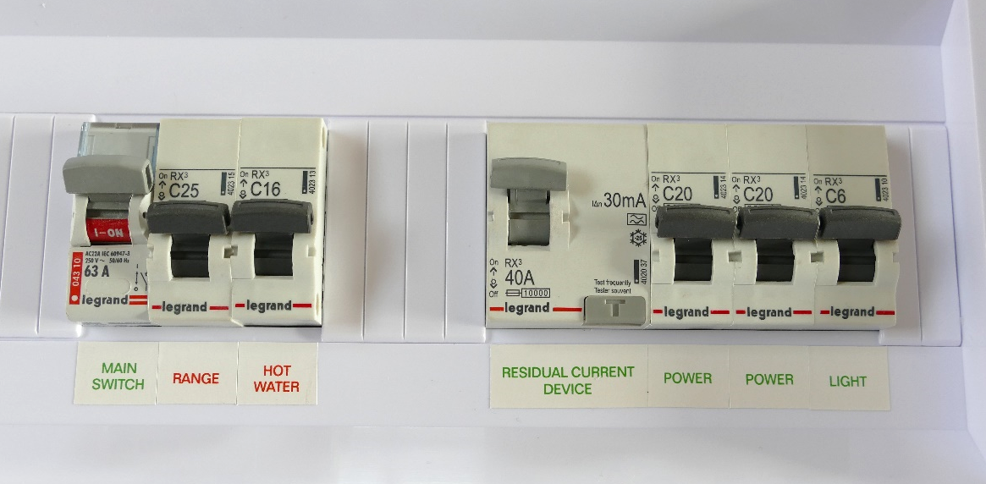
Tick if the hot water circuit in the photo is a subcircuit or submain, and if it is single-phase, two-phase, or three-phase.
Submain | Subcircuit | Single-phase | Two-phase | Three-phase

General tips for writing assessment questions

- Avoid trick questions. Questions should be designed so learners who know the material can find the correct answer.
- Keep the instructions simple. If you must use technical terms, use terms that are familiar with the learner’s situation or terms used in the course material.
- Check grammar – use simple, precise, and clear wording.
- Keep the question or tasks in a logical order.
- Write scenarios if you think they will help the learner understand and answer the question better. Scenarios are good for telling a story and putting the assessment topic into context.
- Have the questions reviewed by someone else to check accuracy, clues, grammar, and ease of questions.

General rules for writing good multiple choice and multiple select questions
Question stem
Correct answer
Distractors – incorrect answers
Which is the third planet from the sun?
- Mars
- Earth
- Uranus
- Jupiter

- The question stem should focus on the learning outcome. Avoid adding irrelevant material as this confuses learners and can waste time.
Ineffective stem | There used to be nine planets in the solar system but now there are eight planets. Which is the third planet from the sun?
Better stem | Which is the third planet from the sun?

- The question stem should be meaningful and be a clear problem statement. Include the main idea in the question.
Stem is not meaningful | Which of the following is a true statement?
Better stem | Which is the third planet from the sun?

- Avoid using negative phrasing - it can make it harder for the learner to understand the question. If you need to use negative phrasing, either bold or italicise to make it clear to the learner.
Stem has negative phrasing | Which of the following is not true?
Stem has negative phrasing | All the following statements about planets are true, except…

- Distractors are the incorrect answers. Distractors should be plausible, and not be obviously wrong.
Obviously wrong  (Popeye is not a real person) | Who was the first to walk on the moon?  A. John Walker  B. Edmund Hillary  - Popeye  D. Neil Armstrong

- Distractors should be written clearly and concisely. The learner’s knowledge of the learning outcome is being assessed, not their reading ability.
- Make the options grammatically consistent with the question stem. Read the stem and the questions to make sure they read correctly.
- The number of distractors vary depending on the number of correct answers. Typically for multi-choice questions there is one correct answer and three distractors.
- Mix up the placement of the correct answer. Be mindful of this because correct answers are usually the second and third option.
- Place the distractors in a logical order.
Distractors not in logical order (dates are not in order from the earliest year to the latest year) | What year did Neil Armstrong walk on the moon?  A. 1954  B. 1980  C. 1969  D. 1963
Logical order | What year did Neil Armstrong walk on the moon?  A. 1954  B. 1963  C. 1969  D. 1980

- Keep the answer options similar in length and language.

- Avoid using ‘all of the above’ as an answer option. Learners only need to recognise two correct options and then choose ‘all of the above’ to get the answer correct.

- Avoid using ‘none of the above’ as an answer option. You will never know if the learner knew the correct answer.

