Supporting and encouraging women in trades

In the past, trades have been heavily dominated by men and seen as a much more traditional career path for males than it has for females. But in the 21st century, trades are becoming a more desirable industry for women to join. With the right kind of support, women will someday make up a large proportion of trades and bring a great deal of wealth and skill to a busy and demanding industry. Having women working in trades future proofs the industry and supplies more resources to the ever-growing demand on trades people.

How to promote women in trades
If we look at how the trades industry has changed over time and what these changes have done, we can see how the industry can become a much more inclusive and diverse sector for women to excel in.
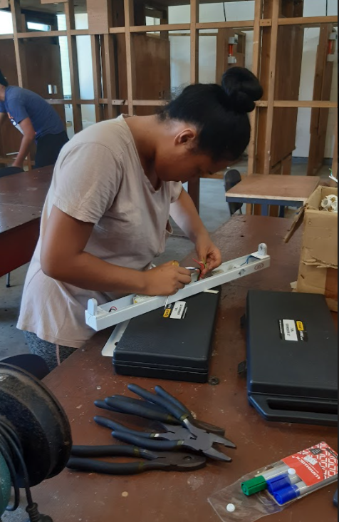
There are a range of ways businesses can be assisted to employ more women in trades roles. The most useful strategies that were found in a 2019 research report were:
- Attracting young women to the trades by campaigning within schools.
- Providing role models for young women to support them into trade roles.
According to this study, businesses that had employed women in the past were much more agreeable with the ideas listed above than those who had never employed female tradespeople at all. But note, the businesses who had employed women had first-hand experience working with women than the employers who had never employed women trade staff.
Providing role models for young women, such as successful women in trades, demonstrates what is possible and what the future holds for trades. If young women see themselves represented in trade magazines and advertisements, this could also increase the idea that women belong in this sector.
A way employers can also promote trades to women is by broadening the base of people they talk to when looking for employees; advertising positions online to vastly open the pool to more people and offering flexible working arrangements that suit for everyone. These arrangements could include part-time hours, staggered hours where staff have different start/break/finishing times, or flexitime which gives staff the freedom of choice and the ability to work hours that give them a better work/life balance.
By creating an inclusive and authentic work culture, women will feel more comfortable choosing a career in trades. By educating current staff about the importance of inclusion and the representation of diversity, organisations can help them safely promote an inclusive work environment that accepts women as valued members of the team.

Benefit of having women in trades
In the same piece of research, it shows that there are great benefits to employing female trade staff. Employers who had employed women found that they paid more attention to detail, they were more careful with work equipment, and that they helped improve the general tone within a workplace.
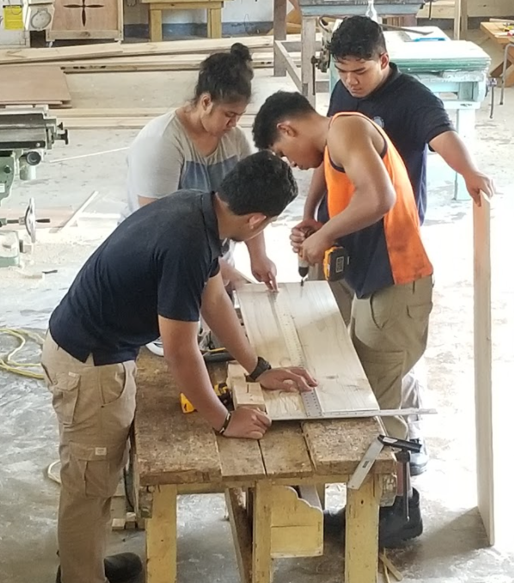
Those who employed women also strongly agreed that women are generally better communicators, particularly when it came to communicating with customers and other staff members. Women helped businesses better reflect their customer base and make the workplace reflect real life with showing diversity in the workplace.
By employing women trade staff, providers and organisations are creating diverse and authentic workplaces. This influences workplace culture and brings a different perspective and different ways of problem solving to any workplace. Only a tiny 7% of employers said they had negative experiences with employing women tradespeople. The negative reasons included how the employer felt the women did not fit in or that the businesses culture was not right for women. But rather than ridiculing women for not fitting an outdated culture, there are ways to create a much more inclusive culture and workplace. For example, welcoming and encouraging women in the workplace. Educating leaders on best ways to support individual employees within a workplace where they originally felt like they didn’t fit in. Communicating with the women trade staff who felt they did not fit in and find a way to bring inclusion to the forefront of other staff members minds. If a leader at a workplace sees the value of women in trades and reinforces the idea, then that culture trickles down to other staff members.
50% of clients who interact with trade staff are women and often like to see that reflected in the trades industry. Women often like to engage with other women and generally feel comfortable with another woman working on their home. The same research found that having women in the workplace changed the attitude of the other staff members. There was less swearing, and people started to treat each other with more courtesy and respect. It saw that as male counterparts changed their attitude towards women in the workplace, they also changed their attitude towards their male colleagues too.
There is a huge demand for trades people, particularly after the pandemic. Construction jobs rose during the pandemic, along with other trades such as electric, gas, water, and waste services. Trades people have been among the rare sectors that continued to flourish throughout the pandemic in this unpredictable job market. The demand outweighs the supply, and by encouraging more women into this career path, the demand can be more easily met.
Case studies of women in trades
Research conducted in New Zealand around employing women into the trades sector discovered that only 14% of employers who had never hired women tradespeople said that they would be unlikely to consider employing a woman in a trades role in the future. And within the same vein, only 18% of those who had employed women tradespeople in the past, but didn’t currently, had the same view.
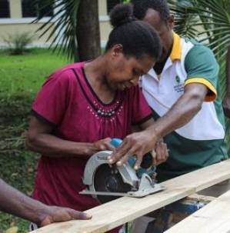
The COVID-19 pandemic has seen millions of people lose their jobs. Trades was an industry that could continue to work throughout some of the different lockdown levels because it is largely essential work. In one case study, a 35-year-old woman is currently completing her first year as an electrical apprentice. After losing her retail job, she decided to move into trades to safeguard her job security. She explained that throughout her experience in her apprenticeship, it is evident that women can bring transferrable skills to trades. She is passionate about creating a safe and inclusive workplace within the trades industry and encourages other women to take the leap into trades too. By employing and encouraging women into the trades industry, we can see an increase in inclusivity and psychological well-being in a traditional ‘men’s’ career path.

Conclusion
Employers fiercely advocated for getting into schools early and sharing stories about women who chose trades as a career and the benefits of doing so. Success for women in trades lies within the stories we tell. If organisations share success stories of women in trades, then it encourages other women to take the plunge and join the industry. Representation is an incredibly important strategy to draw more women into traditionally male dominated careers, if women are shown to be valued in a workplace, then more women will follow in the future. This isn’t just an opportunity for women, but an opportunity for the trades sector to grow, transform and gain more staff to assist with the ever-growing demands placed on trades.

Citations
COVID-19 and the labour market. (2021, March 8). Https://Www.Careers.Govt.Nz/Job-Hunting/Whats-Happening-in-the-Job-Market/Covid-19-and-the-Labour-Market/#cID_10863. https://www.careers.govt.nz/job-hunting/whats-happening-in-the-job-market/covid-19-and-the-labour-market/#cID_10863
Gurchiek, K. (2018, March 19). 6 Steps for Building an Inclusive Workplace. SHRM. https://www.shrm.org/hr-today/news/hr-magazine/0418/pages/6-steps-for-building-an-inclusive-workplace.aspx
Nationwide Survey Launched To Encourage More Kiwi Women Into Trades | Scoop News. (2021, April 14). Https://Www.Scoop.Co.Nz/Stories/BU2104/S00177/Nationwide-Survey-Launched-to-Encourage-More-Kiwi-Women-into-Trades.Htm. https://www.scoop.co.nz/stories/BU2104/S00177/nationwide-survey-launched-to-encourage-more-kiwi-women-into-trades.htm
Skilled Trade Jobs Are Booming in Pandemic Economy. (2021, February 18). Business Wire. https://www.businesswire.com/news/home/20210218005336/en/Skilled-Trade-Jobs-Are-Booming-in-Pandemic-Economy
UMR Market Research, Garrow, L., & Williams, M. (2019, August). How employers have influenced the participation and success of women in trades where they have been traditionally underrepresented. AKO Aotearoa - The National Centre for Tertiary Teaching Excellence.

UMR Market Research, Garrow, L. Williams, M.
UMR Market Research, Garrow, L. Williams, M.
UMR Market Research, Garrow, L. Williams, M.
UMR Market Research, Garrow, L. Williams, M.
SHRM, Gurchiek, K.
UMR Market Research, Garrow, L. Williams, M.
UMR Market Research, Garrow, L. Williams, M.
Careers.govt.nz
Businesswire.com
UMR Market Research, Garrow, L. Williams, M.
Scoop Independent News

